GOOD 1

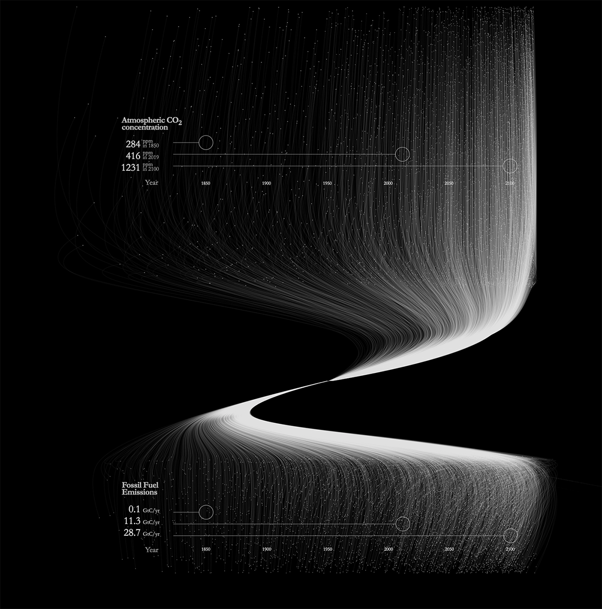

GOOD 2

GOOD 3



The three examples above are considered good because they offer a clear view to the audience, thanks to their detailed use of colour gradients and effective designs. They successfully convey the intended message and achieve the desired impact.  
  
Bad 1  
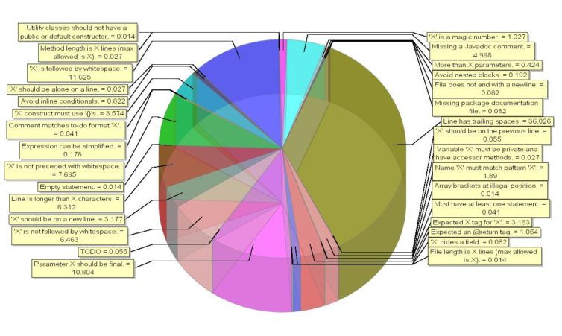

Bad 2  
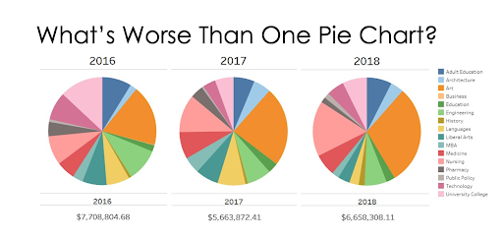

Bad 3

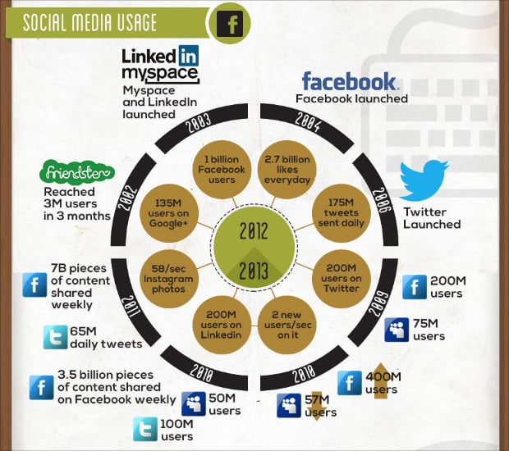

The three examples above are not ideal because they lack clarity and fail to provide a clear view to the audience. Their use of colour gradients is confusing, and the designs are ineffective. As a result, they do not convey the intended message and fail to achieve the desired impact.